Lab: Regular Expressions C#
Problems for in-class lab for the "C# Fundamentals" course @ SoftUni
You can check your solutions in Judge

Match Full Name
Write a C# Program to match full names from a list of names and print them on the console.

Writing the Regular Expression
First, create a regular expression to match a valid full name, according to these conditions:
- A valid full name has the following characteristics:
  - It consists of two words.
  - Each word starts with a capital letter.
  - After the first letter, it only contains lowercase letters afterward.
  - Each of the two words should be at least two letters long.
  - The two words are separated by a single space.
To help you out, we've outlined several steps:
- Use an online regex tester like https://regex101.com/
- Check out how to use character sets (denoted with square brackets - "[]")
- Specify that you want two words with a space between them (the space character ' ', and not any whitespace symbol)
- For each word, specify that it should begin with an uppercase letter using a character set. The desired characters are in a range – from 'A' to 'Z'.
- For each word, specify that what follows the first letter are only lowercase letters, one or more – use another character set and the correct quantifier.
- To prevent capturing of letters across new lines, put "\b" at the beginning and the end of your regex. This will ensure that what precedes and what follows the match is a word boundary (like a new line).
To check your RegEx, use these values for reference (paste all of them in the Test String field):
Match ALL of these | Match NONE of these
Bethany Taylor John Smith | Bethany Taylor, Oliver miller, sophia Johnson, SARah Wilson, John Smith, Sam Smith
By the end, the matches should look something like this:
After you’ve constructed your regular expression, it’s time to write the solution in C#.

Implementing the Solution in C#
Create a new C# project and copy your regular expression into a string variable:
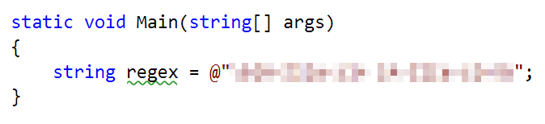
Note: It's usually a good idea to use a verbatim string (@ in front of the string literal) to store regular expressions since characters like the backslash "\" can clash with string escaping.
Now, it's time to read the input and extract all the matches from it. For this, we can use the MatchCollection class:
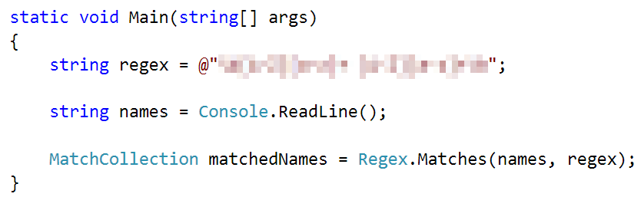
After we extract all the matches, we need to iterate over the MatchCollection and print every match that we found:
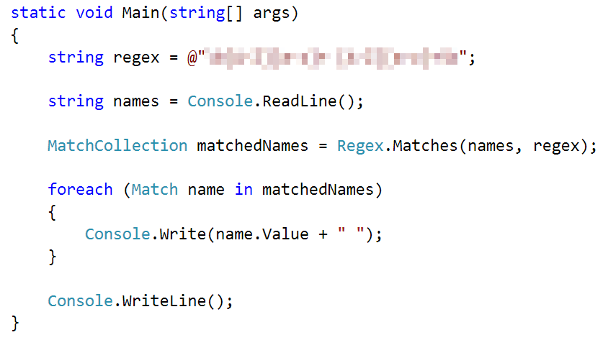

Examples

Input | Output
Bethany Taylor, Oliver miller, sophia Johnson, SARah Wilson, John Smith, Sam Smith | Bethany Taylor John Smith
Elvis Presley a a C C-Muhammad Ali EE PeterpeterJR-a a xi ban D D bb b b-B B-c c EE-Michael Jackson DD peter smith B B PETER BROWN IVAN DAVIES- | Elvis Presley Muhammad Ali Michael Jackson

Match Phone Number
Create a regular expression to match a valid phone number from Sofia. After you find all valid phones, print them on the console, separated by a comma and a space ", ".

Compose the Regular Expression
A valid number has the following characteristics:
- It starts with "+359"
- Then, it is followed by the area code (always 2)
- After that, it’s followed by the number itself:
  - The number consists of 7 digits (separated into two groups of 3 and 4 digits respectively).
- The different parts are separated by either a space or a hyphen ('-').
You can use the following RegEx properties to help with the matching:
- Use quantifiers to match a specific number of digits
- Use a capturing group to make sure the delimiter is only one of the allowed characters (space or hyphen) and not a combination of both (e.g. +359 2-111 111 has mixed delimiters, it is invalid). Use a group backreference to achieve this.
- Add a word boundary at the end of the match to avoid partial matches (the last example on the right-hand side).
- Ensure that before the '+' sign there is either a space or the beginning of the string.
You can use the following table of values to test your RegEx against:
Match ALL of these | Match NONE of these
+359 2 222 2222  +359-2-222-2222 | 359-2-222-2222, +359/2/222/2222, +359-2 222 2222  +359 2-222-2222, +359-2-222-222, +359-2-222-22222

Implement the Solution in C#
Now it's time to write the solution, so let's start writing!
First, just like in the previous problem, put your RegEx in a variable:
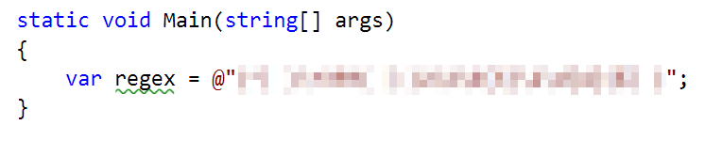
After that, let's make a MatchCollection for our matches:
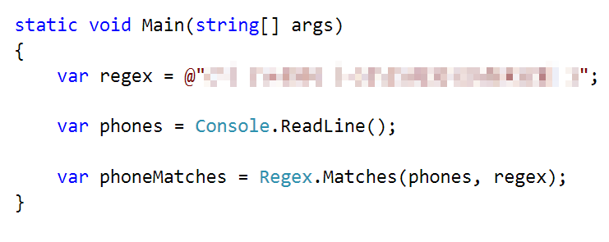
Let's try to print all the matches, using only a single line of code. Since MatchCollection is, as its name suggests, a collection, we can use LINQ methods on it.
To get all of the matches and put them into a string array, we need to perform several manipulations on the MatchCollection:
- Cast every single element of the MatchCollection to the Match type using Cast<Match>().
- Since every element is a Match now, we can extract just the Value property of the match itself, which holds the match value as a string, using Select(). We can also Trim() the value, to get rid of any leading or trailing spaces.
- After getting the match value, we can use ToArray() to convert the collection to an array.
Here’s what that looks like as a LINQ query:
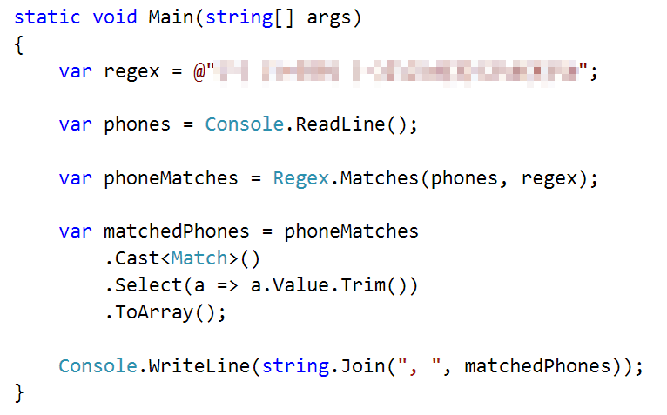
After that, just print the valid phone number array, using string.Join():


Examples
Input | Output
+359 2 222 2222,359-2-222-2222, +359/2/222/2222, +359-2 222 2222 +359 2-222-2222, +359-2-222-222, +359-2-222-22222 +359-2-222-2222 | +359 2 222 2222, +359-2-222-2222
+359 2 234 2324, 359-2-111-9876, +359/8/655/5432, +359-2 222 2222, +359 2-222-2222, +359-2-234-345, +359-2-123-45678, +359-2-222-2222, +359 2 654 1234 | +359 2 234 2324, +359-2-222-2222, +359 2 654 1234

Match Dates
Write a program, which matches a date in the format "dd{separator}MMM{separator}yyyy". Use named capturing groups in your regular expression.

Compose the Regular Expression
Every valid date has the following characteristics:
- Always starts with two digits, followed by a separator
- After that, it has one uppercase and two lowercase letters (e.g. Jan, Mar).
- After that, it has a separator and exactly 4 digits (for the year).
- The separator could be either of three things: a period ("."), a hyphen ("-") or a forward-slash ("/")
- The separator needs to be the same for the whole date (e.g. 13.03.2016 is valid, 13.03/2016 is NOT). Use a group backreference to check for this.
You can follow the table below to help with composing your RegEx:
Match ALL of these | Match NONE of these
13/Jul/1928, 10-Nov-1934, 25.Dec.1937 | 01/Jan-1951, 23/sept/1973, 1/Feb/2016
Use named capturing groups for the day, month, and year.
Since this problem requires more complex RegEx, which includes named capturing groups, we'll take a look at how to construct it:
- First off, we don't want anything at the start of our date, so we’re going to use a word boundary "\b":
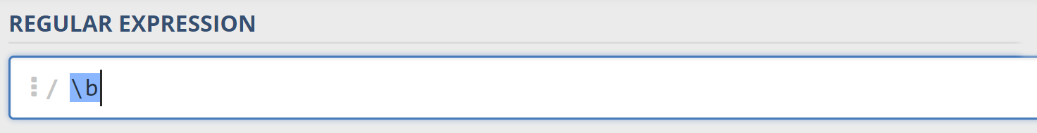
- Next, we're going to match the day, by telling our RegEx to match exactly two digits, and since we want to extract the day from the match later, we're going to put it in a capturing group:
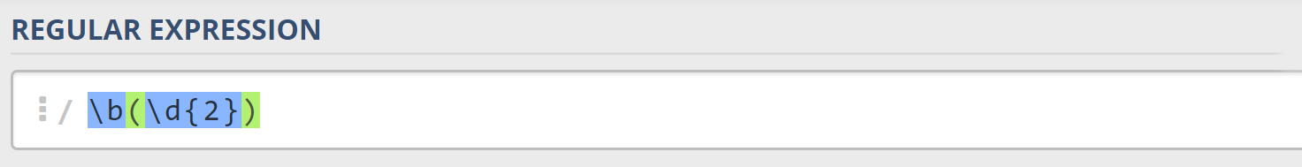
We're also going to give our group a name since it's easier to navigate by group name than by group index:
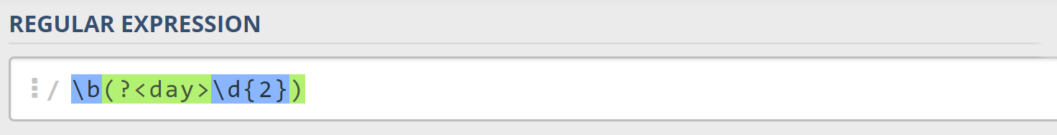
- Next comes the separator – either a hyphen, period, or forward slash. We can use a character class for this:
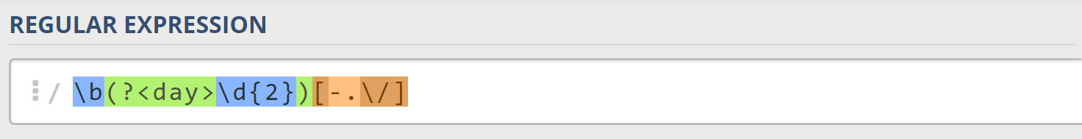
Since we want to use the separator we matched here to match the same separator further into the date, we’re going to put it in a capturing group:
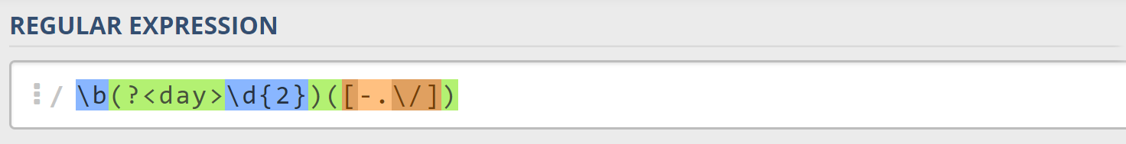
- Next comes the month, which consists of a capital Latin letter and exactly two lowercase Latin letters:
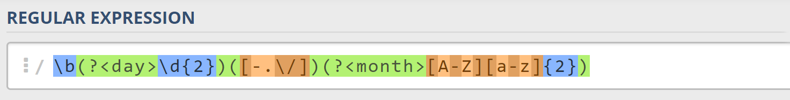
- Next, we're going to match the same separator we matched earlier. We can use a backreference for that:
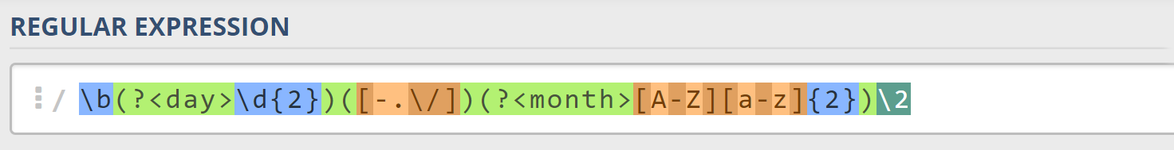
- Next up, we're going to match the year, which consists of exactly 4 digits:
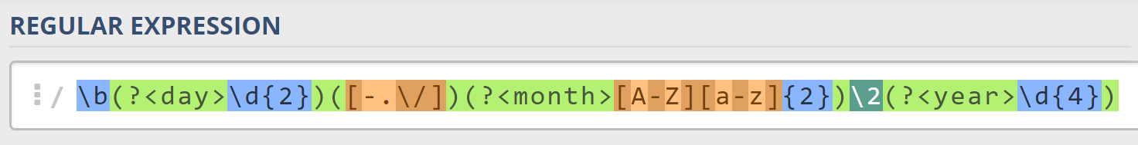
- Finally, since we don't want to match the date if there's anything else glued to it, we're going to use another word boundary for the end:
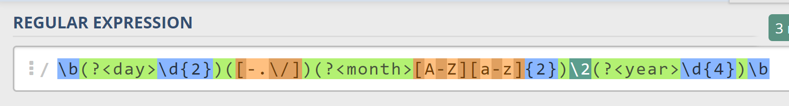
Now it's time to find all the valid dates in the input and print each date in the following format: "Day: {day}, Month: {month}, Year: {year}", each on a new line.

Implement the Solution in C#
First off, we’re going to put our RegEx in a variable and get a MatchCollection from the string:
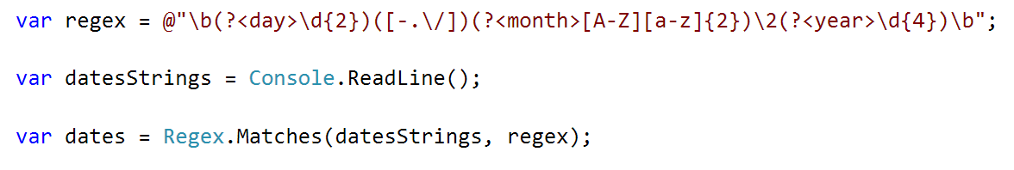
Since RegEx works differently across different languages, before we continue, we're going to set our backreference from \2 to \1. This is because C# backreferences don't count named capture groups for backreferences. So, change it before we continue.
Next, we're going to iterate over every single Match and extract the day, month, and year from the groups. We can use a special syntax in C# to get a match’s group value by its key, the same way as when we access a Dictionary’s values:
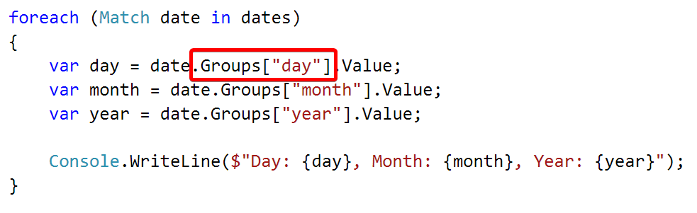

Examples
Input | Output
13/Jul/1928, 10-Nov-1934, , 01/Jan-1951,f 25.Dec.1937 23/09/1973, 1/Feb/2016 | Day: 13, Month: Jul, Year: 1928  Day: 10, Month: Nov, Year: 1934  Day: 25, Month: Dec, Year: 1937
03-Mar-1878, 25/Apr/1915, 31-May-1916, 22/Jun-1941, 25.Dec.1937, 23/09/1973 | Day: 03, Month: Mar, Year: 1878  Day: 25, Month: Apr, Year: 1915  Day: 31, Month: May, Year: 1916  Day: 25, Month: Dec, Year: 1937

